

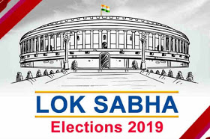

**POLITICAL JUGGERNAUTS: A QUANTITATIVE ANALYSIS OF CANDIDATES IN THE 2019 LOK SABHA ELECTION**

**NM COURSES-DATA ANALYTICS**

***III-B.Sc. MATHEMATICS***

***SRI KGS ARTS COLLEGE SRIVAIKUNDAM***

**POLITICAL JUGGERNAUTS: A QUANTITATIVE ANALYSIS OF CANDIDATES IN THE 2019 LOK SABHA ELECTIONS**

# **PROJECT REPORT**

**INTRODUCTION:-**

**1.1 Overview:**

**\*. “Political Juggernauts: A Quantitative Analysis of Candidates in the 2019 LOK SABHA ELECTIONS is a research study or report that likely delves into a detailed examination of candidates who participated in the 2019 Lok Sabha Elections in India. This study would have likely employed quantitative research methods to analyze various aspects of these candidates and their campaigns.**

**\*. The report would aim to provide a quantitative understanding of the 2019 Lok Sabha Elections by examining data and statistics related to the candidates who participated. Such research is valuable for gaining insights into the dynamics of Indian politics and elections. If you need more specific information about this research or have any particular questions, feel free to ask.**

**1.2. PURPOSE:-**

**\*. The nominations for all phases of the General Election have been submitted. We examine highlights from data on candidates who are participating in the ongoing elections. There are 8,039 candidates contesting for 542 Parliamentary constituency seats.**

1. **PROBLEM DEFINITION & DESIGN THINKING:-**

***2.1. EMPATHY MAP***



***2.2 IDEATION & BRAINSTORMING :***

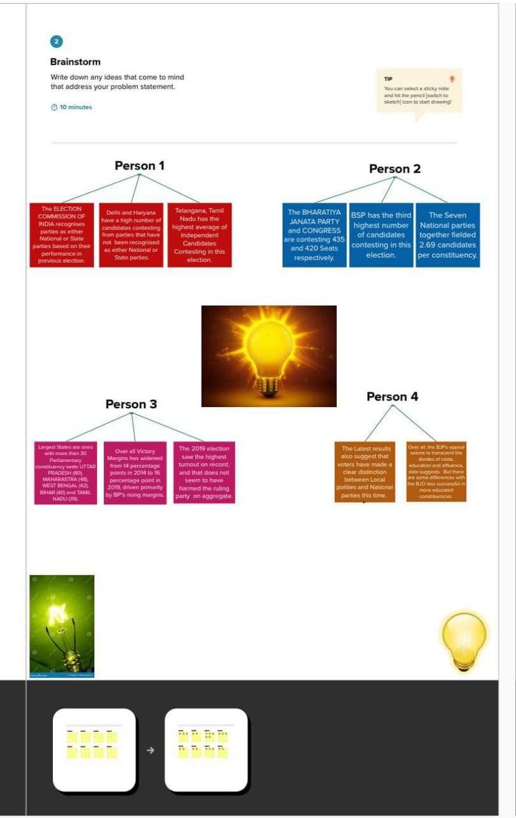

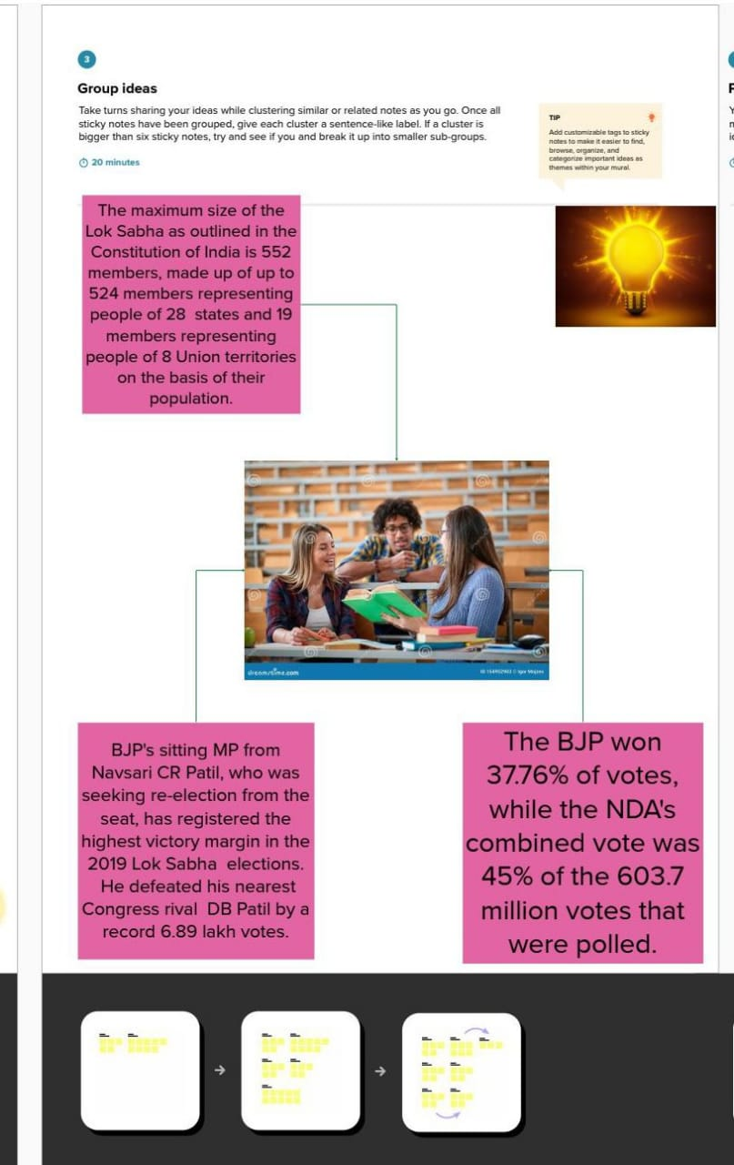

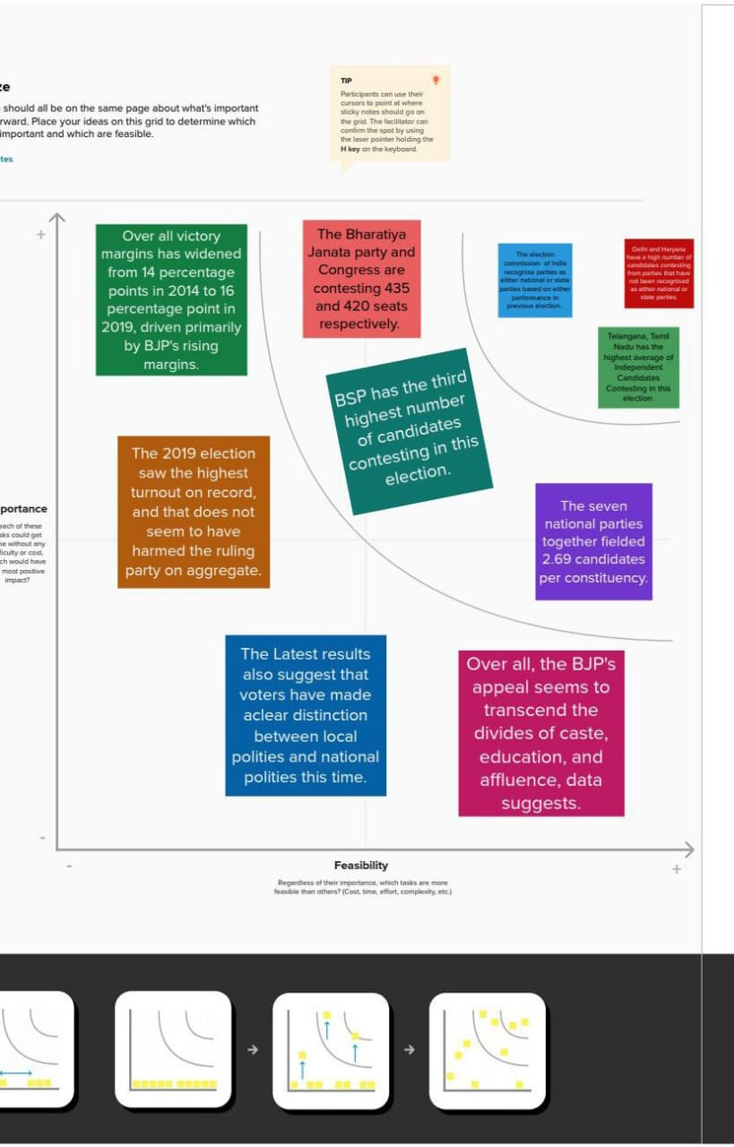

***1.RESULTS***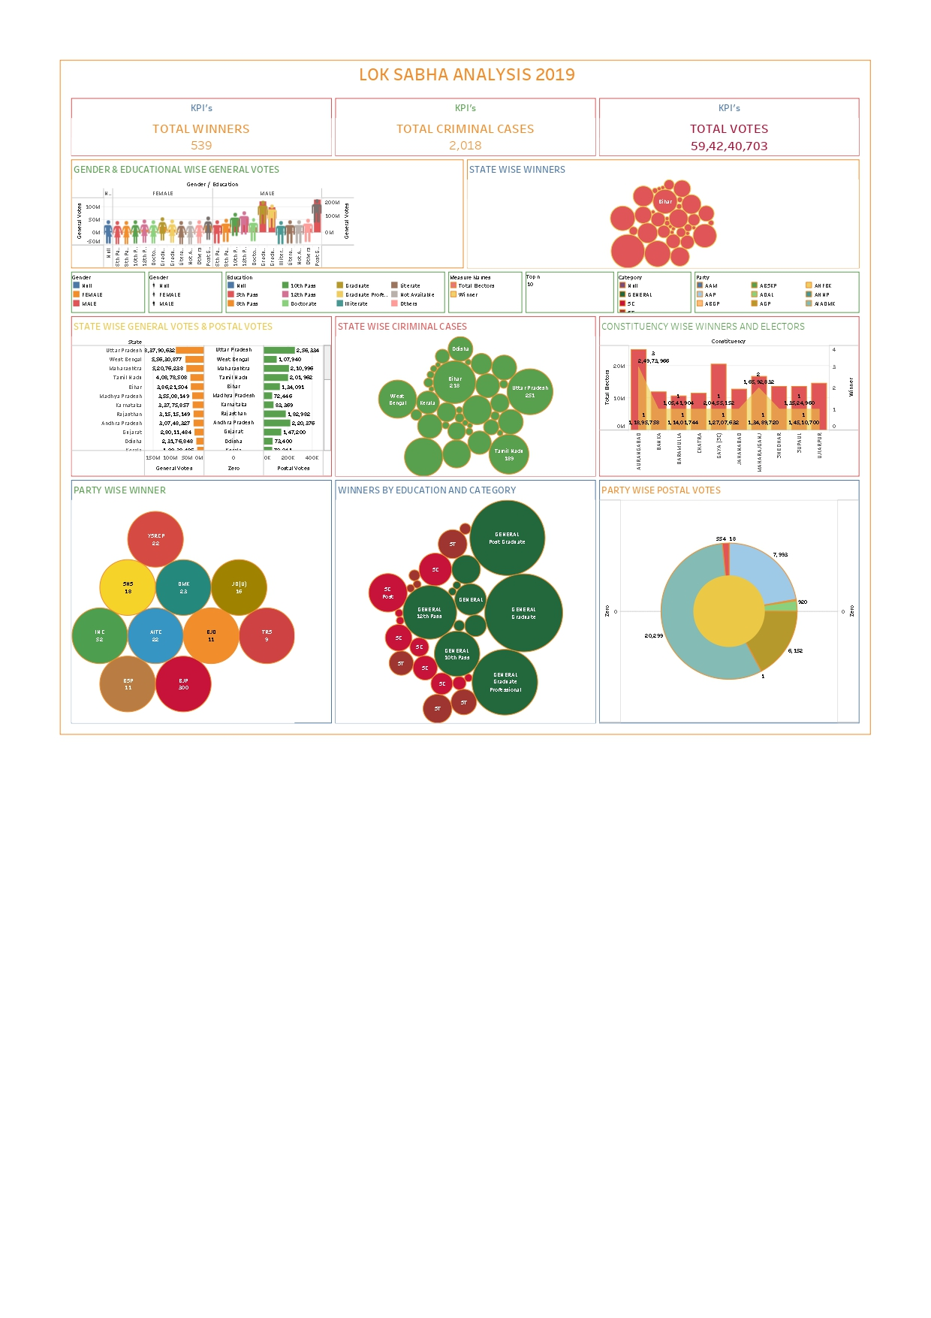

**STORY BOARD**

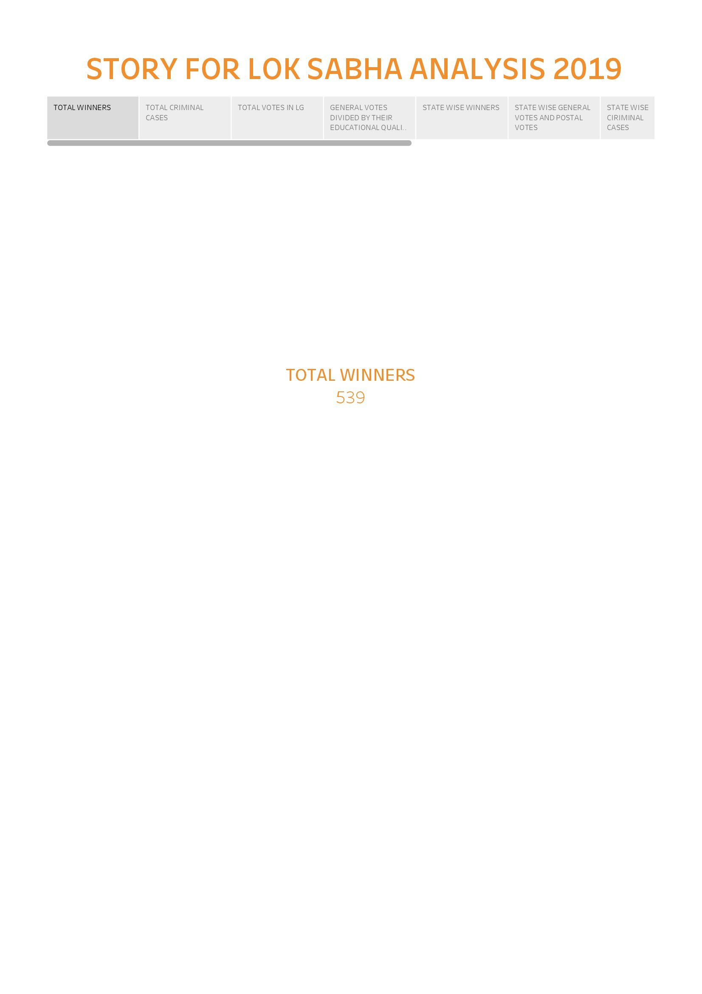

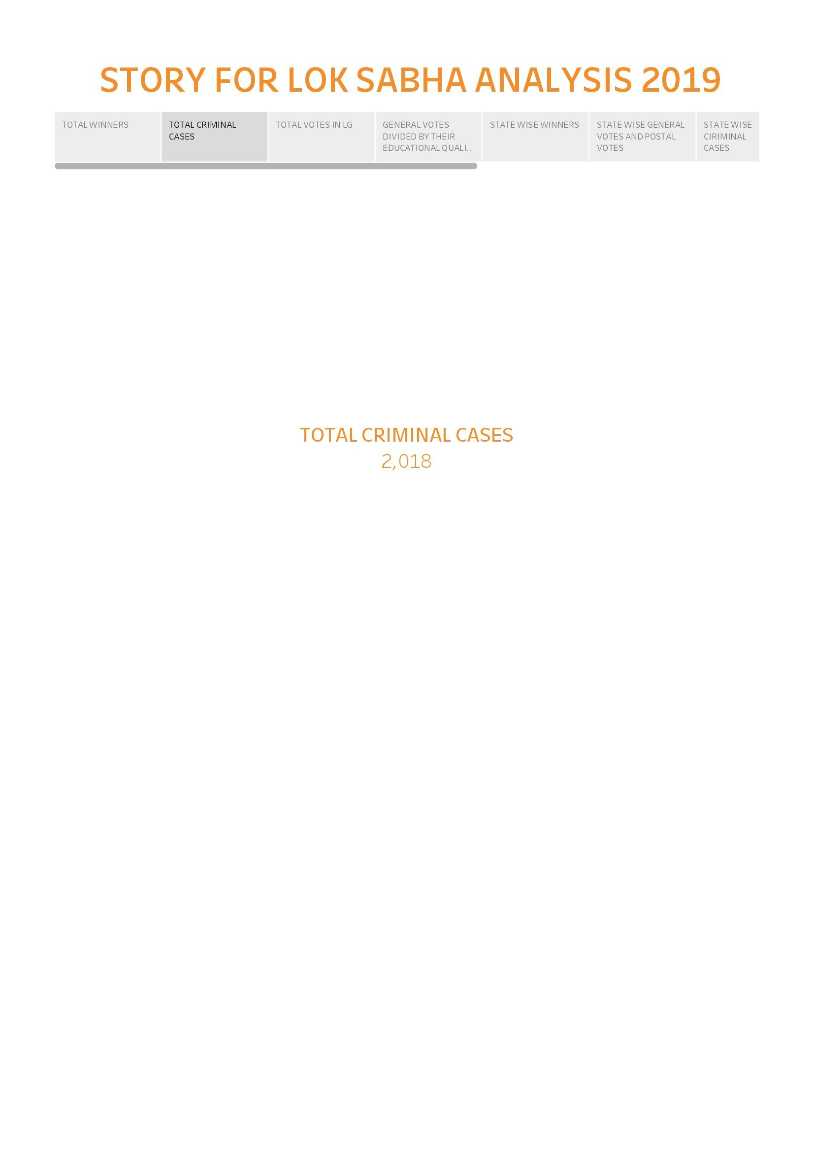

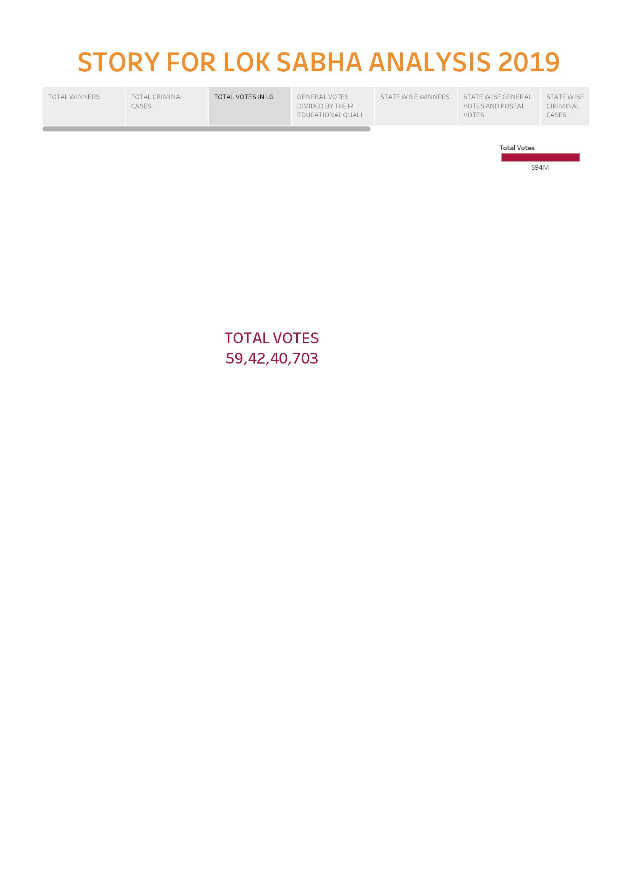

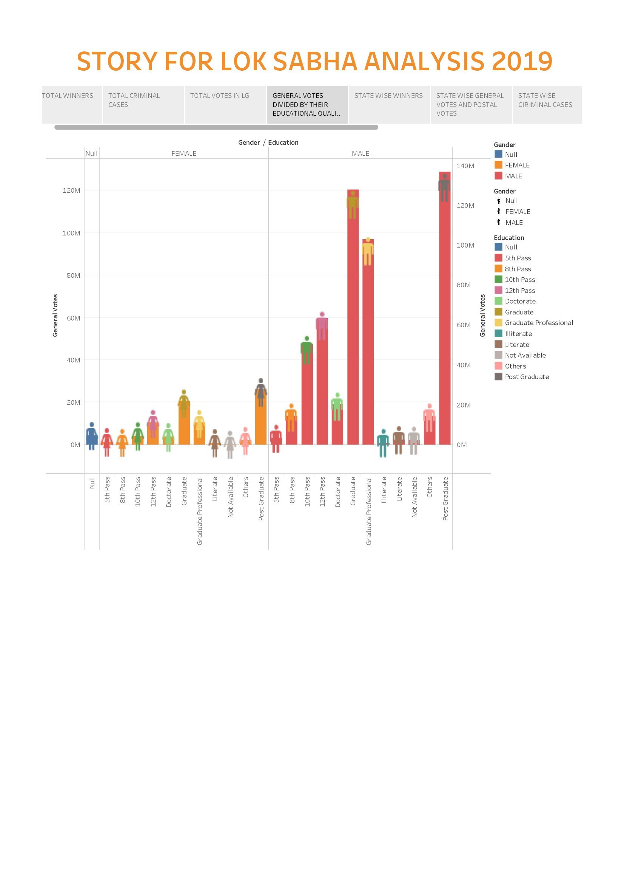

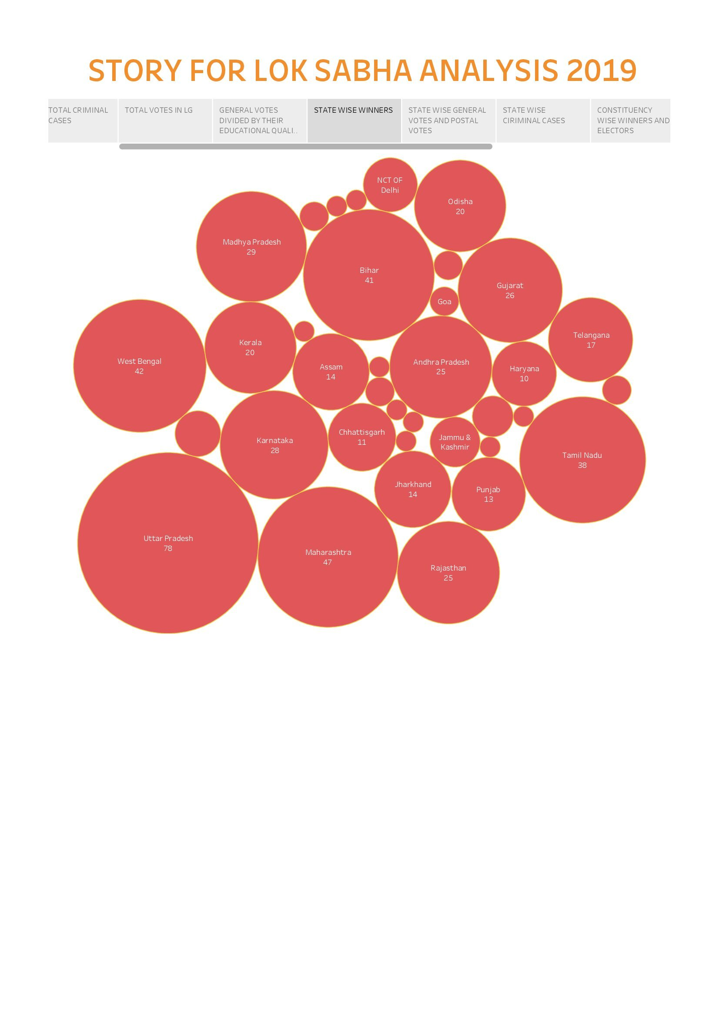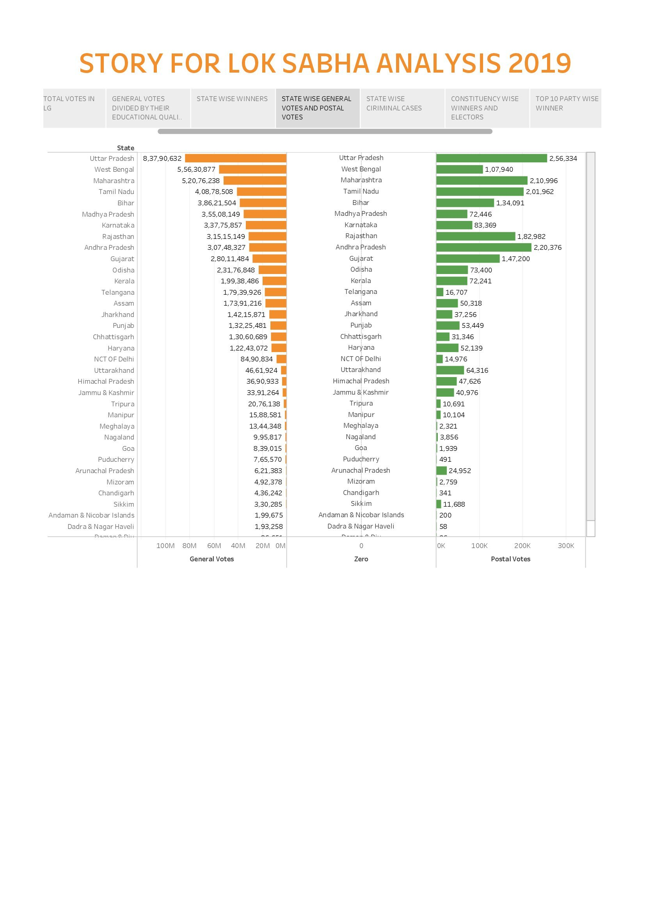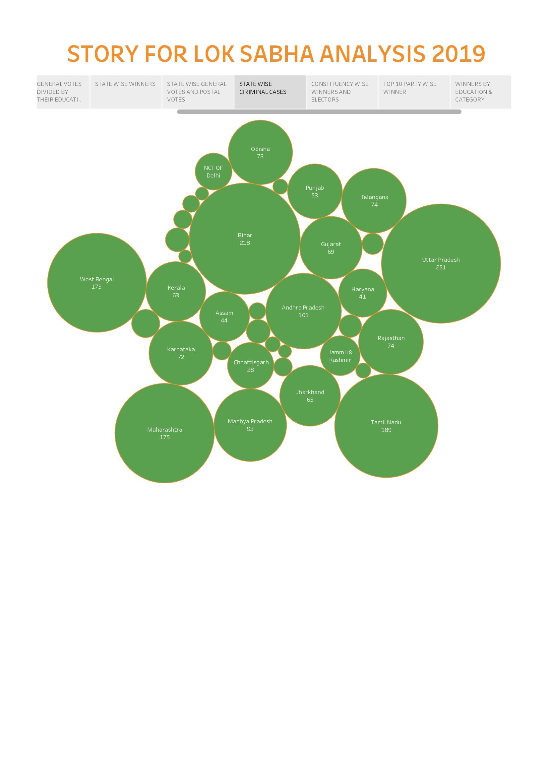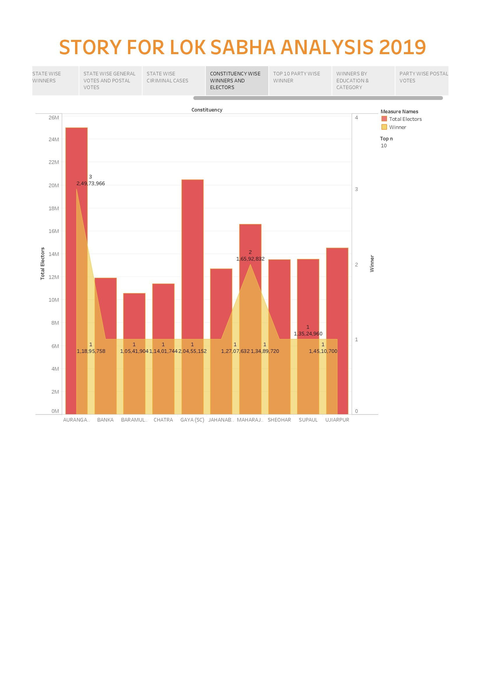

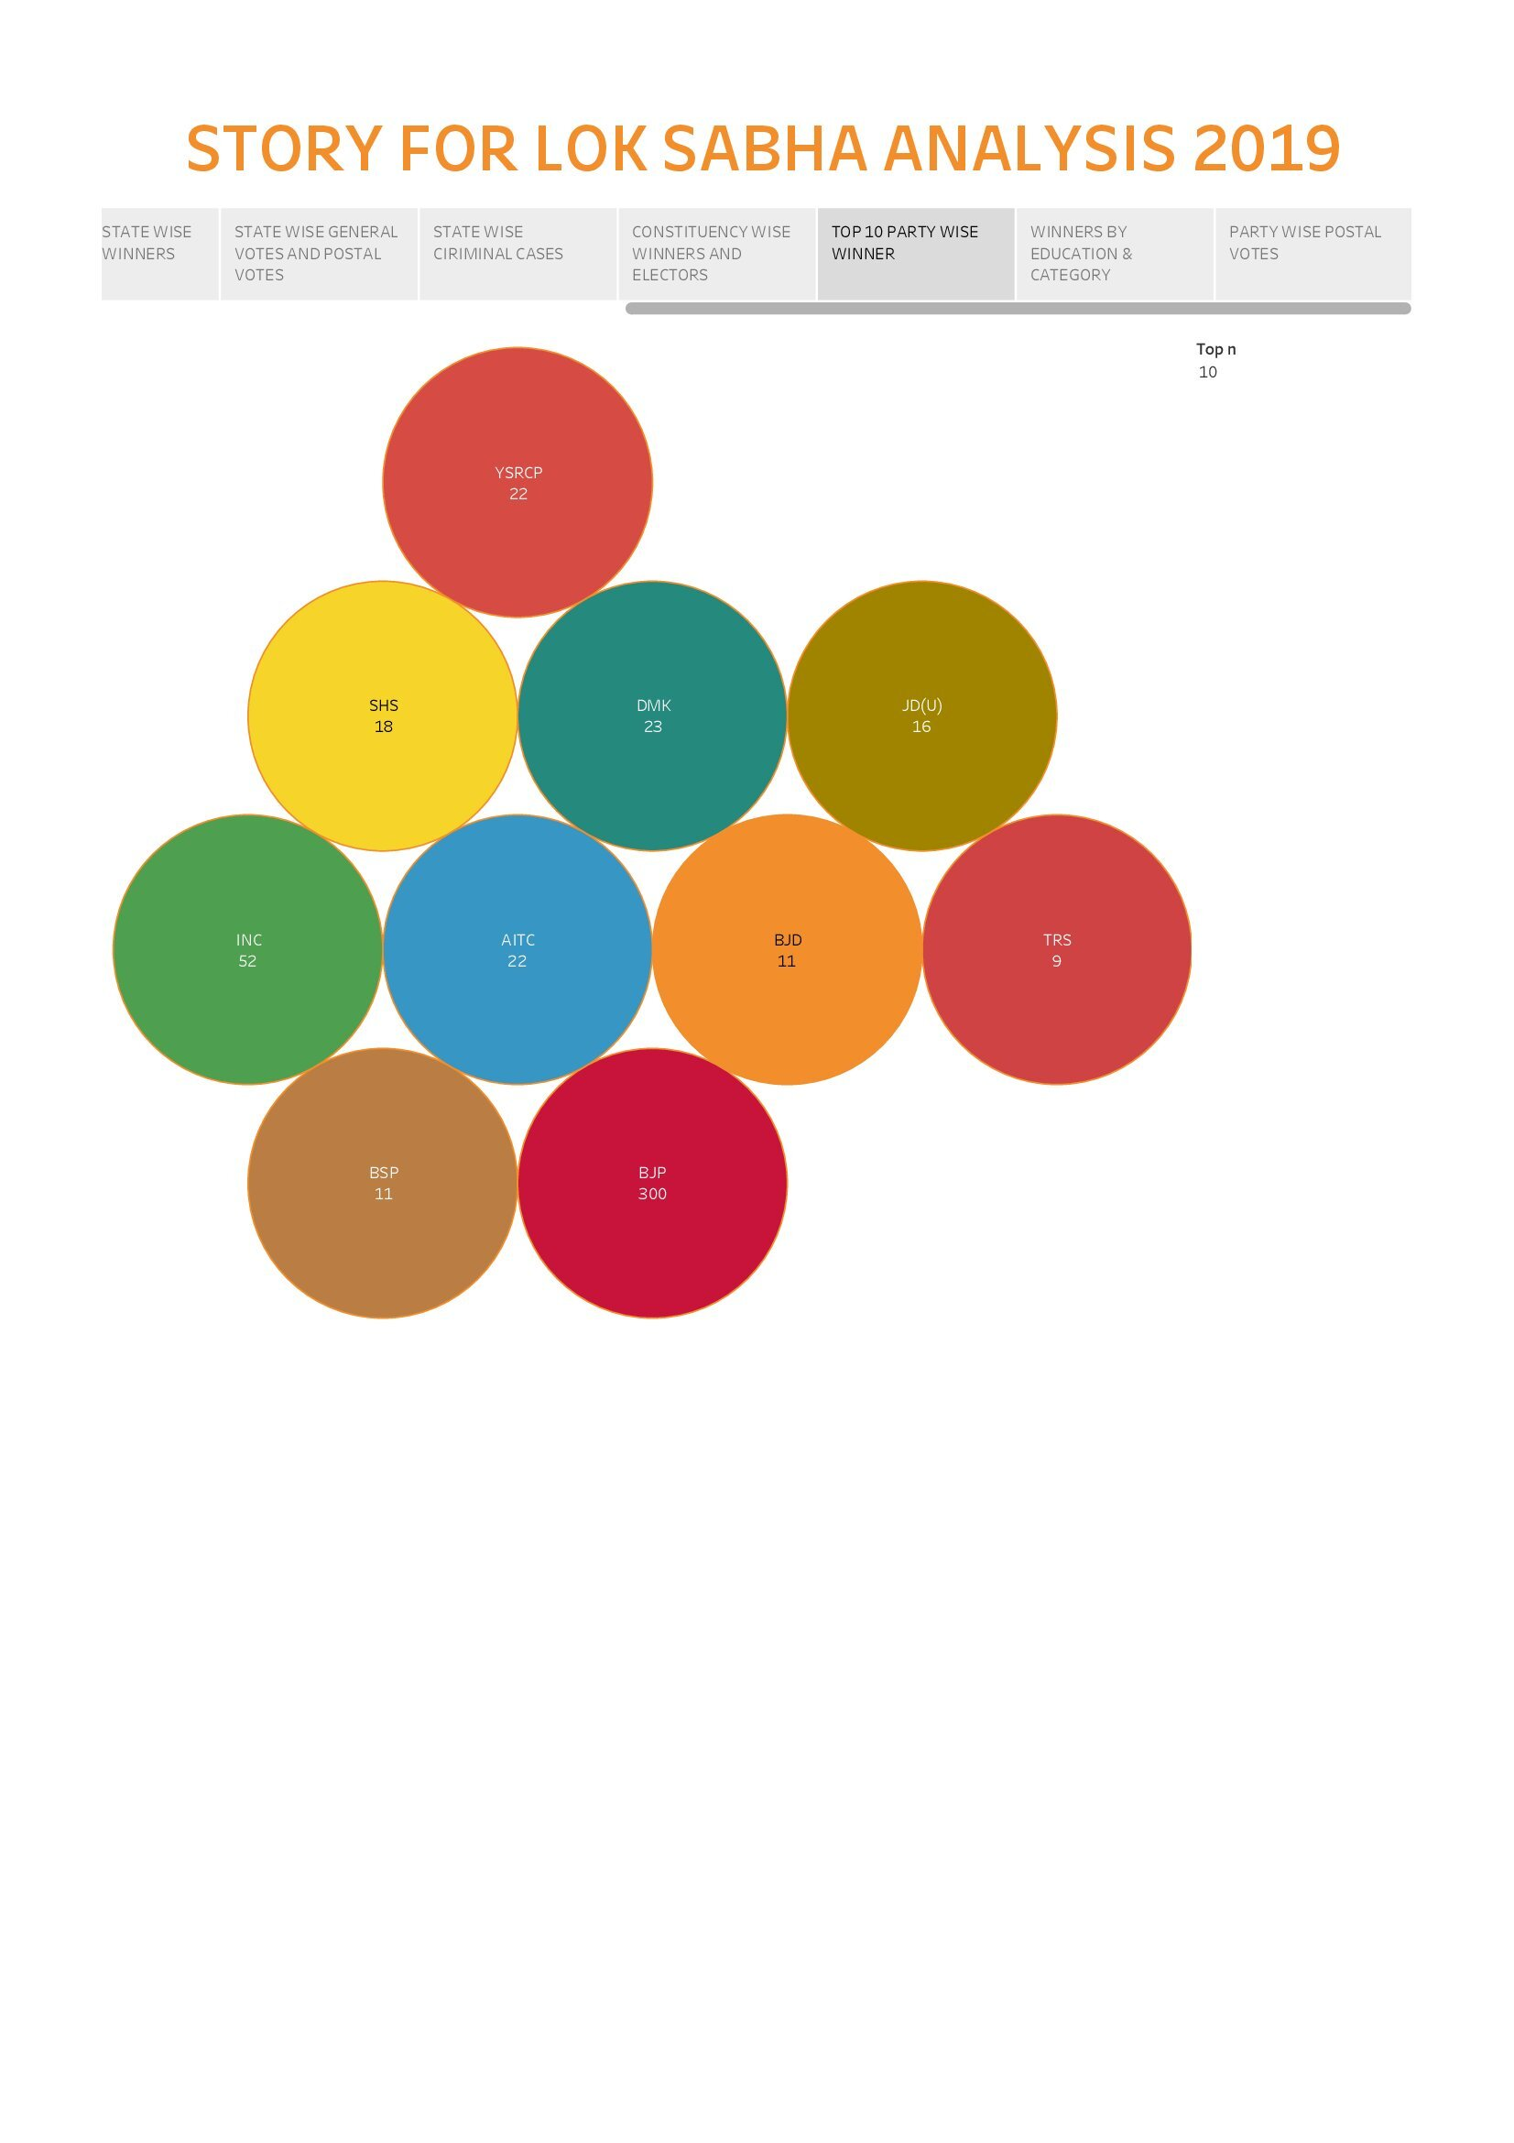

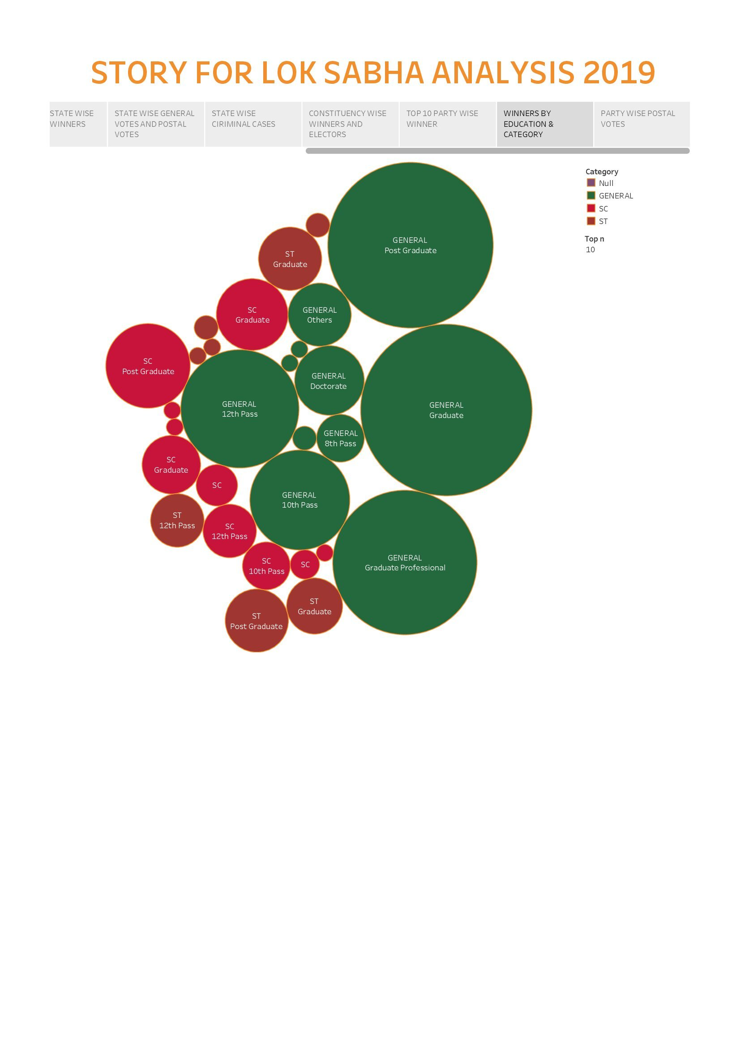

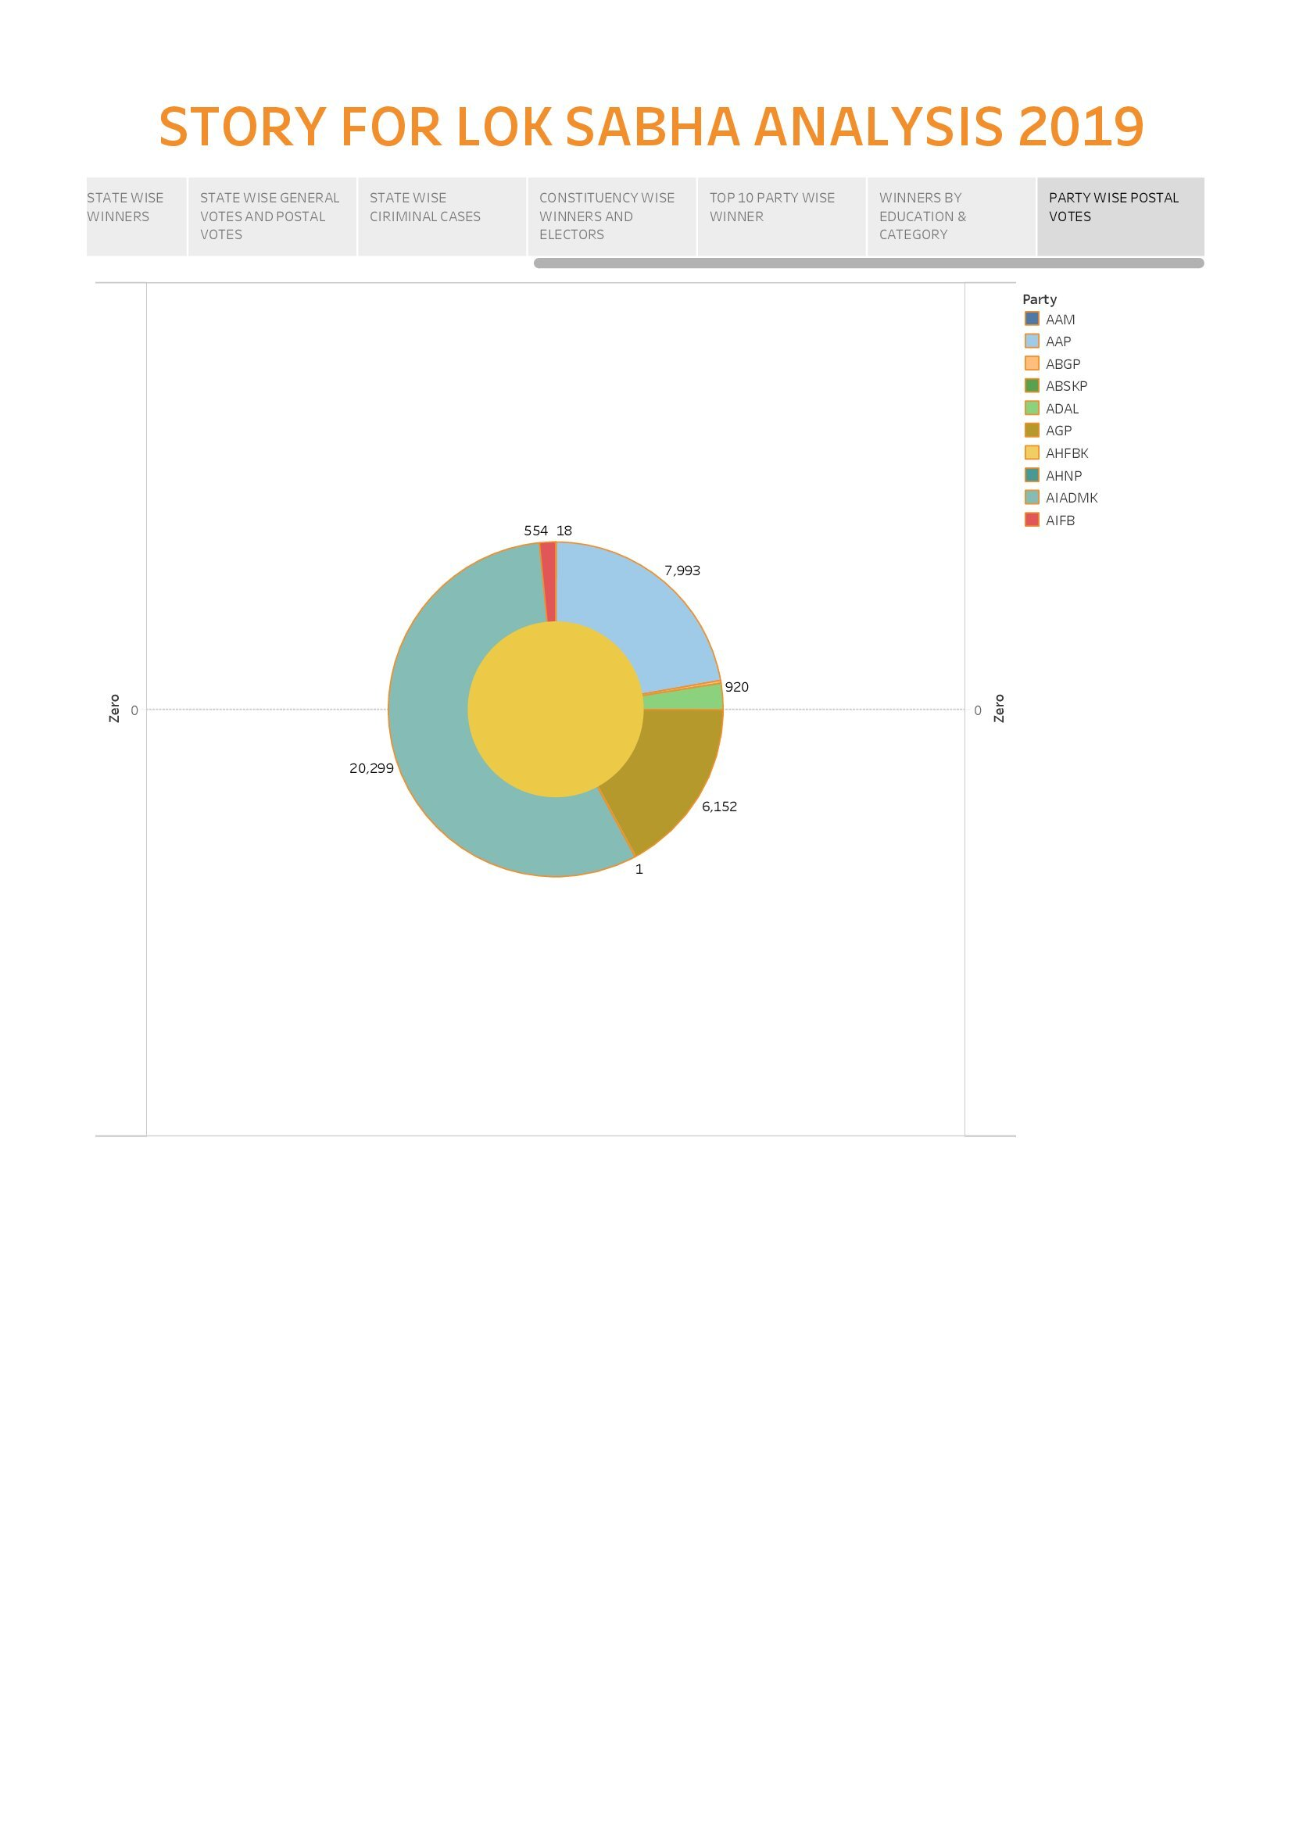***4. ADVANTAGES AND DISADVANTAGES:-***

***Advantages***

1. ***Established candidates and parties are more likely to be recognized by voters due to their history and previous positions in government.***
2. ***Political juggernauts typically have a well-organized party machinery, which includes campaign infrastructure, volunteers, and financial resources.***
3. ***Established candidates and parties tend to have an easier time raising campaign funds, often from corporate donors or loyal supporters.***

***Disadvantages***

* **One major disadvantage is that these political giants tend to overshadow smaller parties and independent candidates, limiting the diversity of voice in the political landscape.**
* **Established politicians often rely on tried-and-tested strategies, which can lead to a lack of innovation and fresh policy ideas.**
* **Juggernauts tend to concentrate power within a few individuals or families, leading to concerns of dynastic politics and reduced accountability.**

**5.APPLICATIONS:-**

* **Quantify the popularity of candidates associated with major political parties. This could involve examining their social media following, rally attendance, or media coverage.**
* **Analyze voter turnout in constituencies where political juggernauts campaigned or held rallies. Did their presence significantly increases voter participation.**
* **Calculate the winning percentage of candidates affiliated with political juggernauts. were they more likely to win than other candidates.**
* **Quantitatively assess the campaign spending of political juggernauts and its correlation with electoral success.**
* **Analyze the impact of political juggernauts’ policy positions on vector behavior through surveys and opinion polls.**

**6.CONCLUSION:-**

* **The Quantitative analysis of Candidate in the 2019 Lok Sabha Elections reveals important insights into the political landscape of that period. This study sheds light on the demographic and educational backgrounds of candidates, their criminal records, and the dynamics of party affiliations. While it offers valuable data and trends, it’s important to remember that the political landscape is ever-evolving. This analysis provides a snapshot of that particular election and can serve as a foundation for further research and a better understanding of the Indian political system. It underscores the need for continued scrutiny and informed participation in the democratic process to ensure representative governance and accountability in the future.**

**7.FUTURE SCOPES :-**

* **Assess the performance of political juggernauts in the 2019 Lok Sabha Elections. Analyze factors such as the number of seats won, margin of victory, and vote share.**
* **Study how political juggernauts performed in different regions and among various demographic groups. This can provide insights into their future electoral prospects in specific areas.**
* **Examine the role of alliances and coalition politics in the 2019 elections. This can shed light on potential future alliances and their impact on juggernauts.**
* **Explore the potential for leadership transition within political parties and how it might affect the future of political juggernauts.**

**APPENDIX:-**

**A. Source Code**

**Dashboard**

<https://public.tableau.com/views/DASHBOARDFORLOKSABHAANALYSIS2019/Dashboard1?:language=en-US&:display_count=n&:origin=viz_share_link>

**Story**

[**https://public.tableau.com/views/STORYFORLOKSABHAANALYSIS2019/Story1?:language=en-US&:display_count=n&:origin=viz_share_link**](https://public.tableau.com/views/STORYFORLOKSABHAANALYSIS2019/Story1?:language=en-US&:display_count=n&:origin=viz_share_link)

**THANK YOU**